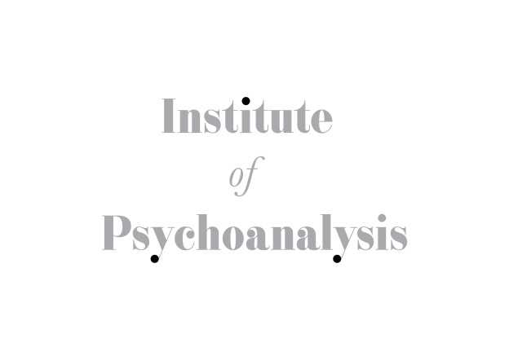
JOB TITLE:
E-learning & Audio Visual Technician

PURPOSE OF THE JOB:
- To support the Head of Learning Technologies & Bespoke Courses
- To be responsible for the recording and editing of e-learning material
- Create courses in the e-learning platform (Moodle)

DUTIES & RESPONSIBILITIES:
- To record and edit material for e-learning and other activities of the Institute
- Set up courses in Moodle under the direction of the Head of Learning Technologies & Bespoke Courses
- To liaise with the Institute Manager about co-ordinating various tasks
- Responsible for audio and visual recordings of Wednesday evening meetings (8 – 10.30pm)
- Work with the Archivist on the archives’ audio visual project if required
- Under the coordination of the Head of Learning Technologies & Bespoke Courses to liaise with the membership for recording lectures/public events run by the Institute and undertake the recordings when appropriate
- To edit the website when required
- Share in general office activities including reception/telephone cover
- Provide cover as required for absent staff (sickness / holiday)

REPORTING TO:
- Head of Learning Technologies & Bespoke Courses

WORKING HOURS:
- Part-time 3 days a week, 2 years renewable contract. Flexibility with days and hours is essential. During busier periods there will be opportunities to work more days. Weekend and evening work may also be required.

HOLIDAY ENTITLEMENT
- 25 days pro rata

SALARY
- Circa £25,000 pro rata, depending on experience. Possibility of earning overtime on various projects.

PERSON SPECIFICATION

KNOWLEDGE & EXPERIENCE:

Essential:
- Experience of Adobe Premier Pro filming and editing software
- Experience in filming

Desirable:
- Experience of filming and editing in an educational setting which includes the use of AV equipment in lecture halls/seminar rooms
- Experience of Moodle
- Experience with website editing software

SKILLS/ ATTRIBUTES:
Essential:
- Ability to work under pressure and to tight deadlines
- Eye for style, format and layout of course material (Moodle design)
- Excellent communication skills
- Ability to plan ahead and anticipate problems
- Ability to relate to and deal sympathetically with the membership and public
- Able to solve problems creatively
- Ability to work within a team and contribute to the overall effort
- Positive and willing attitude to dealing with work problems

Desirable:
- Understanding of working within a membership framework
- Knowledge of psychoanalytic concepts

EDUCATION:
Essential:
- A Bachelor degree or equivalent experience/qualification.

