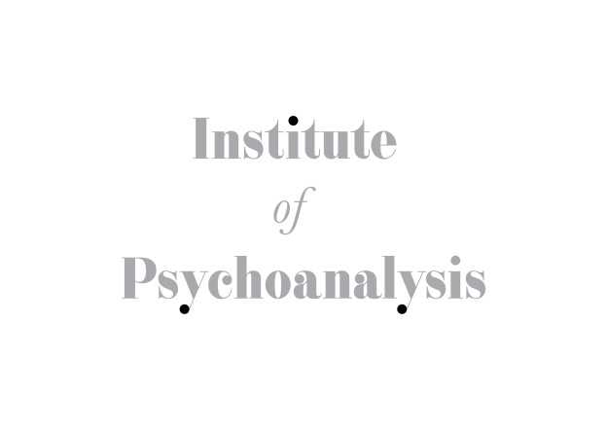
JOB TITLE:
Archivist

PURPOSE OF THE JOB:
- To support the work of the Archives Committee
- To provide support and advice to the Chair of the Archives Committee
- To manage the collections of the British Psychoanalytical Society

DUTIES & RESPONSIBILITIES:
- To run the archives' enquiry service, handling requests received by telephone, e-mail and post and supervising research visitors
- To manage access to the collections, in conjunction with the Honorary Archivist
- To catalogue records of the British Psychoanalytical Society/Institute of Psychoanalysis and deposited collections of personal papers
- To establish and develop contact with other archives in London and beyond in order to help and promote research and education
- To maintain and develop the accessions register
- To revise and develop archive policies on acquisitions, access etc
- To monitor and assess the preservation needs of collections and repackage archival material as appropriate
- To maintain the archives' web pages and online catalogues
- To promote the archives collections by preparing exhibitions, leaflets etc and participating in occasional outreach work
- To recruit and manage occasional volunteers
- To order archival supplies as needed and to liaise with the Institute's finance department regarding budgets, income etc..,
- Other reasonable duties in keeping with this position
- Share in general office activities including reception/telephone cover
- Provide cover as required for absent staff (sickness / holiday)

REPORTING TO:
- Institute Manager

WORKING HOURS:
- Part-time 3 days a week

HOLIDAY ENTITLEMENT
- 25 days pro rata

SALARY
- Circa £26,000 - £28,000 pro rata.

PERSON SPECIFICATION

KNOWLEDGE & EXPERIENCE:
Essential:
- Experience of working in an archives environment (minimum 2 years)
- Experience of handling archives enquiries and supervising researchers
- Experience of cataloguing institutional records and personal papers
- Knowledge of international archive cataloguing standards, including ISAD(G)
- Knowledge of archives conservation issues
- Knowledge of copyright and data protection legislation relevant to archives
- Strong IT skills
- Strong oral and written communication skills
- Strong organisational and time management skills
- Ability to work independently with minimal supervision

Desirable:
- Experience of a membership organisation
- Experience of managing archives volunteers
- Knowledge of German language

SKILLS/ ATTRIBUTES:
Essential:
- Strong IT skills
- Strong oral and written communication skills
- Strong organisational and time management skills
- Ability to work independently with minimal supervision
- Ability to plan ahead and anticipate problems
- Ability to relate to and deal sympathetically with the membership and public
- Able to solve problems creatively
- Ability to work within a team and contribute to the overall effort
- Positive and willing attitude to dealing with work problems

Desirable:
- Understanding of working within a membership framework
- Knowledge of psychoanalytic concepts

EDUCATION:
Essential:
- A Postgraduate qualification in archives studies

